Name: ________________________________ Date: ___________________________________

Class: _________________________________ Teacher: ___________________________________

# Math Mini Quiz 6

This Mini Quiz, we’re going to explore the math concepts that you’ve learned so far in this unit. This assignment should take you about **20 minutes**.

1) Each of the equations is given in one of the forms that we talked about in class (standard, factored, vertex). For each one, ***label the form*** and ***write and label the other two remaining forms***

a) *y = 2(x - 5)(x + 1) → factored form*

*Standard Form*

*2(x2-4x-5)*

*2x2-8x-10*

*Vertex Form*

*2(x2-4x-5)*

*2(x2-4x + 4) + 2(-4-5)*

*2(x-2)2-18*

b) *y = (x - 1)2 - 4 → vertex from*

*Standard Form*

*x2 - 2x + 1 - 4*

*x2 - 2x - 3*

*Factored Form*

*x2 - 2x - 3*

*(x - 3)(x + 1)*

c) *y = 2x2 + x - 1 → standard from*

*Factored Form*

*(x + 1)(2x -1)*

*Vertex Form*

*2(x2 + x/2 - 1/2)*

*2(x2 + x/2 + 1/16) + 2(-1/2 -1/16)*

*2(x + ¼)2 + 2(-7/16)*

*2(x + ¼)2 - 7/8*

2) Below you have the graph representing the shape of a contact lens[1], often considered a more convenient way of correcting vision than glasses. Its shape follows a quadratic equation (similar to the parabolic example we did in class). 

Write the function *y(x)* to express the shape of the contact lens. You may write it in any form that you would like. You may need to do some work, but not a lot of work to reach your answer.

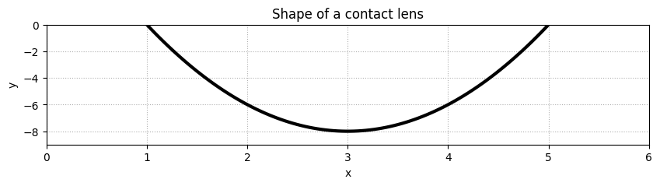

*The solution can most conveniently be found with either vertex or factored form.*

| *Factored Form:*  *In factored form, we know that we have the form $y=a(x-x_{0,1})(x-x_{0,2})$*  *Where $x_{0,1}$ and $x_{0,2}$ are the zeros or x-intercepts of the graph. Here we see the x intercepts occur at 1 and 5. So, our equation looks like: $y=a(x-1)(x-5)$*  *Finally, we need to find a, which we can do by plugging in any point on the graph. For example, the graph goes through $(2, -6)$, so if we plug that in:*  *y =a (x - 1)(x - 5)*  *-6 = a (2 - 1)(2 - 5) = a (1)(-3) = -3a*  *a = 2*  *So the equation becomes $y=2(x-1)(x-5)$* | *Vertex Form*  *In vertex form, we know that we have the form $y=a(x-h) + k$*  *Where $h_{}$ and $k$ are the x and y coordinates of the vertex. Looking at the graph, we can see that the vertex occurs at (3, -8). So the equation looks like $y=a(x-3) - 8$*  *Be careful of the sign of h and k. Now, like with the factored form, we see that the graph goes through $(2, -6)$, so if we plug that in to solve for a:*  *y =a (x - 3) + 8*  *-6 =a (2 - 3) + 8 = -a + 8*  *a = 14*  *So the equation is $y=14(x-3) - 8$*  *Notice that the a in the vertex and factored forms aren’t necessarily the same* |
| --- | --- |

1. Contact lens image from https://www.healthline.com/health/eye-health/how-to-put-in-contact-lenses